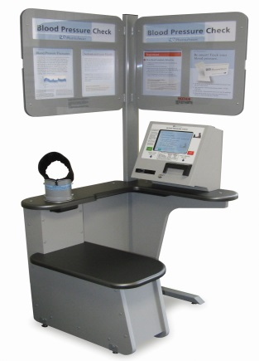
Why should you know your blood pressure numbers?
- If your blood pressure numbers stay high, you increase your risk of getting heart disease and stroke.
- Most people experience no symptoms from having high blood pressure, yet over time, it can damage the entire body.

Use the blood pressure machine at JBS to learn YOUR numbers!
- Follow the instructions on the wall by the machine to check your blood pressure.

The blood pressure machine is located near the cafeteria and occupational health in the main building.

