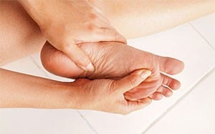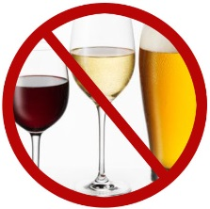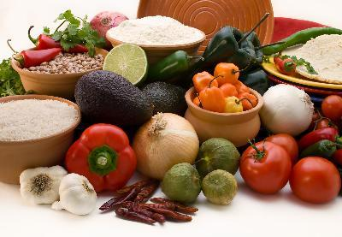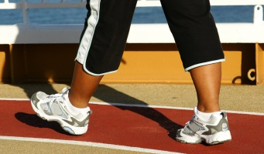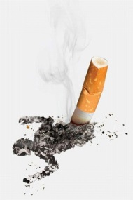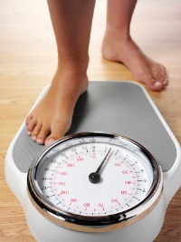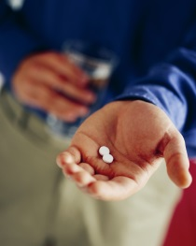HEALTHY LIVING GOAL SHEET

Not at all

A little

Somewhat sure

Very sure

Not at all

A little

Somewhat important

Very important

Choose one goal at a time

What will I do?__________________________________________________________________________

When/where will I do it?_________________________________________________________________

How often will I do it?___________________________________________________________________

What might get in the way of me doing this?_____________________________________________

What can I do to make sure my plan works?_____________________________________________

Goal Review

How important is this goal to you? (circle one)

How sure are you that you will reach this goal? (circle one)

If Diabetic: